Name : Tazmeen Afroz Roll No : 22P-9252
Section : BAI-5A
Instructor : Saad Ahmad

OS-LAB-2
list all the files names starting with a

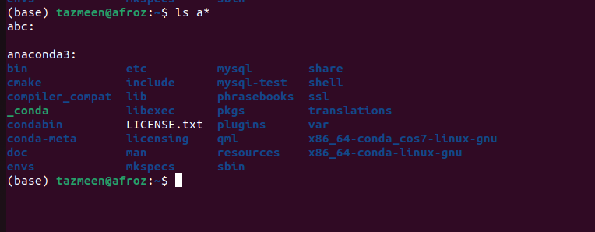
create a main directory in Desktop
Then create 5 more directories in main
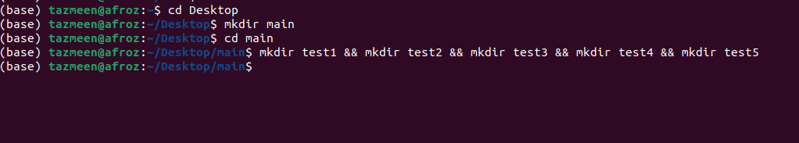

rm is used for remove list not directories
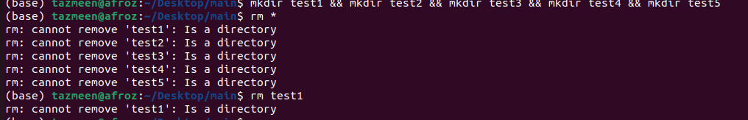

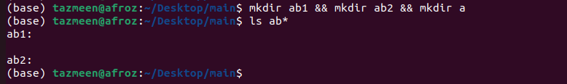
ls ab* give all directories

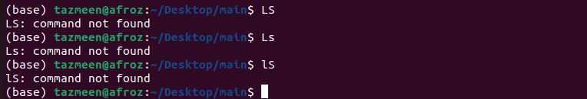
auto-completion
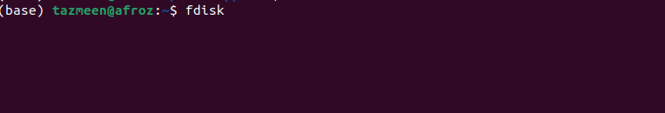
fd and fdi + tab give fdisk

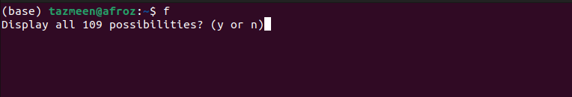
f + tab (give you all the files starting with f)

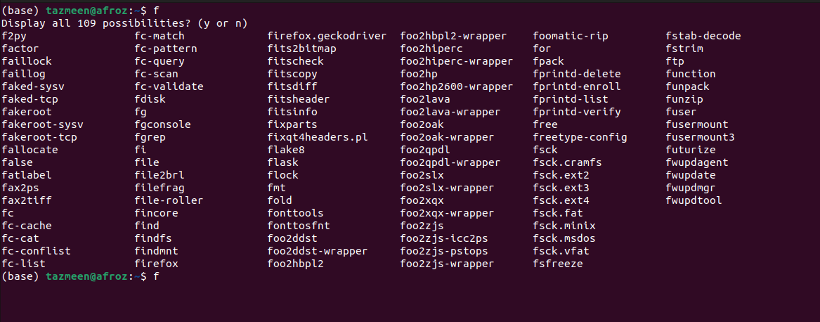

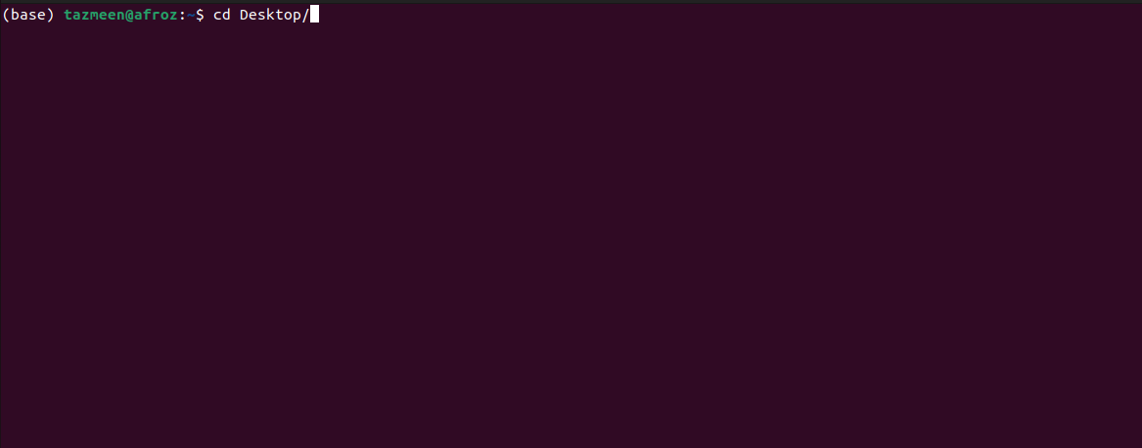
cd Des + tab

cd home/tazmeen/a + tab

cd home/tazmeen/Dow + tab

ls for listing all the files
cd to move to directory
mkdir to create a new folder
rmdir to delete that folder
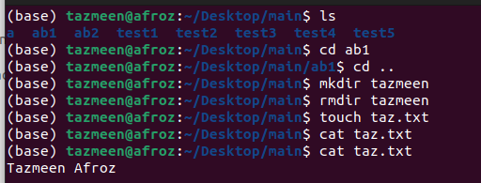

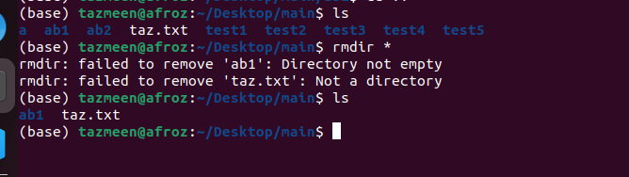
remove all director ies in main directory

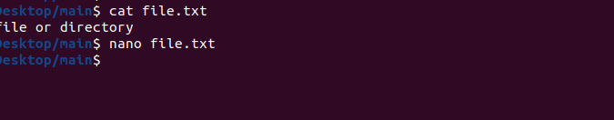

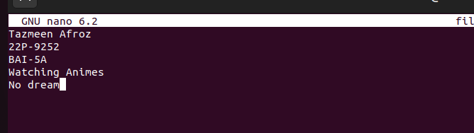

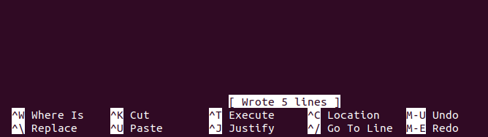


copy
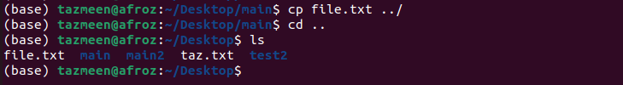

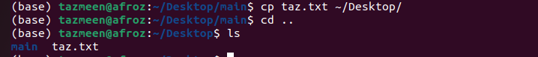

move

